AI in Telecommunications & Networks
Course Portfolio — Final Exam Submission
Prepared by: K. Campomanes
Modules 1 – 13

Introduction
This portfolio compiles my activities, assignments, laboratory exercises, and reflections across all modules of the AI in Telecommunications and Networks course. Each section below summarizes what the module covered, the work I completed (assignments and hands-on labs), the results I obtained, and what I learned from the experience. Screenshots of graphs generated in my Python notebooks, along with diagrams and tables, are included throughout. Citations to external sources used in lectures and assignments are noted in the References section at the end of this document.

Module 1: Fundamentals of Telecommunications Systems

Activities
For this module I completed Assignment 1, which covered the definition and scope of telecommunications, the basic components of a communication system, analog vs. digital signals and performance metrics, and how network topology and architecture affect different types of communication.

Key Concepts & Results
Definition and Scope
Telecommunications is the exchange of information over distance using electronic means — everything from phone calls and text messages to streaming, fiber-optic backbones, and satellite links. It spans wired and wireless networks, the internet, broadcasting, and mobile communications.
Core Components of a Communication System
Every communication system is built from three core parts: a transmitter that converts a message (e.g., voice) into a transmittable signal, a channel (wired or wireless) that carries the signal and is also where noise and interference are introduced, and a receiver that picks up and decodes the signal. I illustrated this flow, including the noise path, in the diagram below.
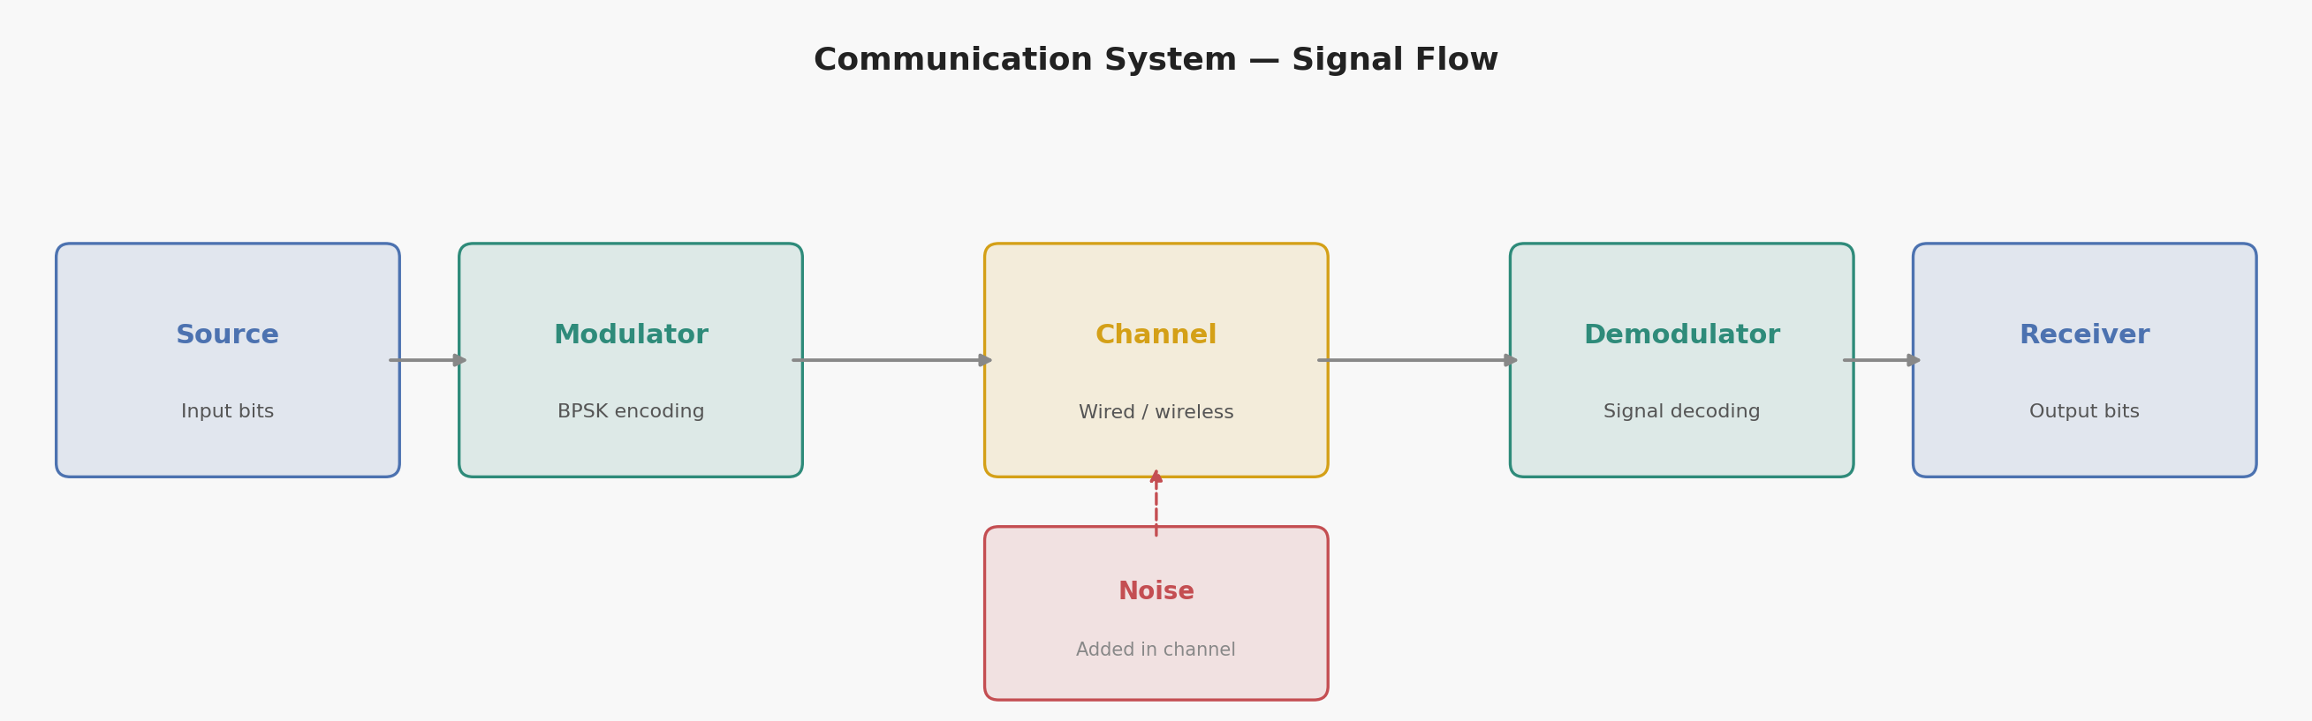
Figure 1.1 — Signal flow of a generic communication system: Source → Modulator → Channel (with noise) → Demodulator → Receiver.
Analog vs. Digital Communication
Analog signals vary continuously (e.g., FM radio) and are highly sensitive to noise. Digital signals use discrete 0/1 values (e.g., computer data) and are more robust to noise, more efficient, and easier to regenerate cleanly — which is why digital systems dominate modern networks. Key performance metrics I studied include Signal-to-Noise Ratio (SNR), bandwidth, latency, and throughput.
Communication Types and Network Topology
The four communication types covered were voice, data, video, and multimedia (which combines all three, e.g., video calls). Network topology and architecture strongly influence how well each type performs:
- Bus — simple and cheap, but a single point of failure and poor scalability.
- Star — easy to manage; a device failure doesn't bring down the network, but the central hub is a single point of failure.
- Ring — predictable performance, but one broken link disrupts the whole loop.
- Mesh — highly reliable due to multiple paths, but expensive and complex.
- Hybrid — combines topologies (e.g., star + mesh) for flexibility and scalability; common in real enterprise networks.

Reflection
This module gave me the vocabulary and mental model I used throughout the rest of the course: nearly every later module — RF propagation, RAN architecture, 5G core, security — is really an elaboration of the transmitter–channel–receiver model and the tradeoffs between topology choices.

Module 2: Network Architecture & Wireless Basics

Activities
This module's lecture covered the OSI and TCP/IP models, core vs. access network concepts, RF spectrum and propagation, and the evolution of cellular networks from 1G to 5G. I also completed Assignment 2 (on 5G Core concepts) and Laboratory 2, a hands-on Python simulation of Free-Space Path Loss (FSPL).

Lecture Summary: OSI, TCP/IP, and Access/Core Networks
The OSI model defines 7 layers for network interoperability; for this course the Application, Transport, Network, Data Link, and Physical layers were emphasized. The TCP/IP suite is the practical, 4-layer protocol stack that actually runs the Internet (Application, Transport, Internet, Network Access). An Access Network connects end-user devices (Wi-Fi, LTE, 5G) to a Core Network, which is the high-capacity backbone that routes traffic between access networks and out to the Internet or AI services.
Cellular Evolution (1G → 5G)
- 1G — analog, voice only (1980s).
- 2G — digital, voice & SMS, introduced SIM cards.
- 3G — enabled mobile internet and video calls.
- 4G — high-speed broadband, HD streaming.
- 5G — ultra-low latency, IoT, and automation, purpose-built for AI-driven services.

Assignment 2: 5G Core Concepts
Assignment 2 addressed five questions on 5G core networking:
- EPC vs. 5GC — EPC (4G) was built for mobile broadband; 5GC is cloud-native, uses a Service-Based Architecture (SBA) with API-driven network functions, and supports ultra-low latency, massive IoT, and automation.
- Network slicing — dividing one physical 5G network into multiple virtual networks tuned to specific needs (e.g., autonomous vehicles need ultra-low latency; IoT sensors need massive low-power device support; video streaming needs high bandwidth).
- Multi-access Edge Computing (MEC) — placing compute at the network edge to shorten the data path and cut latency, critical for self-driving cars, AR/VR, and AI video analytics.
- AI in dynamic resource allocation — AI predicts congestion, allocates bandwidth, and optimizes spectrum use in real time.
- Network Repository Function (NRF) — in 5G's SBA, the NRF acts as a service registry / directory so network functions can discover and communicate with each other.

Laboratory 2: Free-Space Path Loss (FSPL) Simulation
Purpose: model how signal strength decays with distance for a 2.4 GHz Wi-Fi signal, using the standard FSPL formula (in dB): FSPL = 20·log10(distance) + 20·log10(frequency) + 32.44.
I implemented this in Python (NumPy/Matplotlib), sweeping distance from 0.1 km to 20 km and plotting the resulting path loss curve:
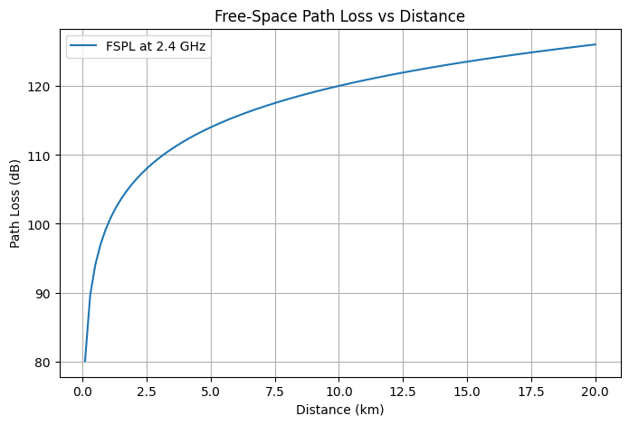
Figure 2.1 — Free-Space Path Loss vs. distance at 2.4 GHz.
Results
Path loss increases logarithmically with distance: roughly 80 dB at 0.1 km, climbing to about 126 dB at 20 km. This confirms why wireless signal strength drops quickly at first and then more gradually, and why real deployments need additional access points or higher transmit power to maintain coverage over longer distances.

Reflection
Connecting the OSI/TCP-IP theory with the FSPL simulation made the abstract idea of a 'wireless channel' concrete: I could see numerically why coverage planning is a real engineering constraint, not just a slide bullet point.

Module 3: AI/ML in RAN, Self-Organizing Networks & Open RAN

Activities
This module covered how AI and machine learning are applied inside the Radio Access Network (RAN), Self-Organizing Network (SON) concepts, and the shift from traditional RAN to Open RAN. I completed Assignment 3 and Laboratory 3, a Random Forest model that predicts telecom network traffic.

Assignment 3: AI/ML Applications in RAN
Radio Resource Management & Network Reliability
AI/ML can analyze traffic patterns to allocate bandwidth more efficiently during congestion, and can detect unusual patterns (e.g., early hardware degradation at a base station) before they cause an outage.
SON and Predictive Maintenance
- Self-optimization — automatically tunes power levels, frequency assignments, and handover parameters.
- Self-healing — detects faults and lets neighboring cells compensate for a failed site.
- Predictive maintenance — AI anticipates equipment failures before they occur, reducing downtime and improving QoS.
Normalizing User Demand (hands-on concept)
Normalizing user demand scales different users' resource requests to a common range so they can be compared and allocated fairly — directly analogous to real-world Open RAN scheduling, where limited resources must be shared fairly across many users with different needs.
Traditional RAN vs. Open RAN
Traditional RAN is single-vendor with proprietary interfaces. Open RAN disaggregates hardware and software and uses open, standardized interfaces, allowing multi-vendor interoperability and reducing dependence on any one supplier.
RAN Intelligent Controller (RIC)
The Near-RT RIC operates on a millisecond-to-second timescale for real-time optimization (e.g., traffic steering, handover optimization). The Non-RT RIC operates on longer timescales, handling network analytics, policy management, and AI/ML model training that the Near-RT RIC later applies.

Laboratory 3: Predicting Network Traffic with Random Forest
Goal: build a model that predicts hourly telecom traffic (Gbps) from time-based and lag features, similar to how a SON or Non-RT RIC would forecast demand for capacity planning.
I generated a synthetic year of hourly traffic data with realistic daily, weekly, and seasonal patterns plus a business-hours boost, engineered lag features (1-hour and 24-hour lag, 7-day rolling average), and explored the data before modeling:
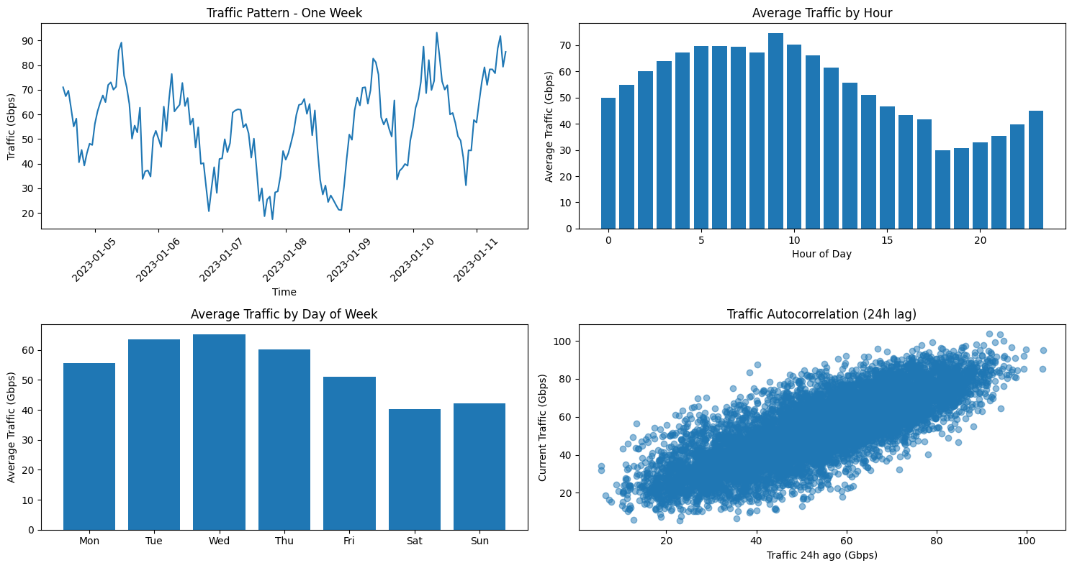
Figure 3.1 — Exploratory analysis: weekly traffic pattern, average traffic by hour and day of week, and 24-hour autocorrelation.
I then trained a Random Forest Regressor (100 trees, max depth 10) on an 80/20 train/test split:
Metric | Training Set | Test Set
MSE | 17.59 | 34.64
R² | 0.946 | 0.893

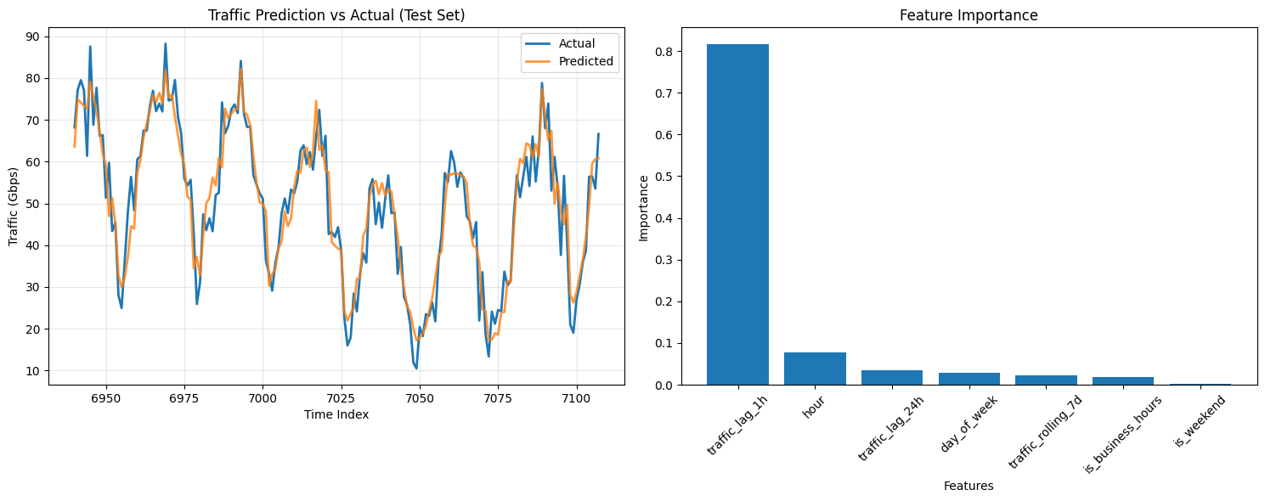
Figure 3.2 — Predicted vs. actual traffic on the test set (left) and feature importance (right).
Results
The model explained about 89% of the variance in held-out test traffic (R² = 0.893). Feature importance showed that the most recent hour's traffic (1-hour lag) was by far the strongest predictor (importance ≈ 0.82), far outweighing hour-of-day, 24-hour lag, day-of-week, or the 7-day rolling average.

Reflection
Seeing how dominant the 1-hour lag feature was helped me understand why real SON/RIC systems lean so heavily on very recent measurements for short-term forecasting, while longer-term features (like day-of-week) matter more for capacity planning than for moment-to-moment optimization.

Module 4: AI-Driven Load Balancing in Paravirtualized 5G Networks

Activities
For this module I read and reviewed the peer-reviewed paper “AI-Driven Load Balancing in Paravirtualized 5G Networks: Architecture, Implementation, and Future Prospects” by Mobara, Moskolaï Ngossaha, Djeumen Djatcha, Tchappi, and Bowong Tsakou (Procedia Computer Science, 2025), presented at the 16th International Conference on Ambient Systems, Networks and Technologies (ANT 2025).

Summary
The paper opens with the scale of the problem: mobile data traffic has been growing rapidly, and video alone already makes up the large majority of mobile data traffic, so no single access technology can keep up with demand on its own. The authors argue that 5G's ultra-high bandwidth and low latency create new load-management challenges at the network edge as more services and applications compete for the same resources.
Their proposed system combines three technologies — Software-Defined Networking (SDN), Network Functions Virtualization (NFV), and a paravirtualized server layer (built on Synology hardware) — supervised by two AI models: an unsupervised model that manages optimal communication between servers, and a supervised model that distributes load based on a live monitoring dashboard of each server's saturation level.
Architecture
The architecture has three layers: a 5G router providing connectivity, a Synology layer containing paravirtual servers and an AI agent that monitors and balances load between them, and a user-facing layer where the AI agent routes incoming requests to whichever server is least loaded.
Results
The paper reports throughput comparisons before and after AI integration. Without AI, typical download/upload speeds were around 100/20 Mbps under normal load, rising to about 400/50 Mbps under peak load. With the AI-driven load balancer active, speeds improved to roughly 180/40 Mbps under normal load and 600/100 Mbps under peak load.
Condition | Download (Mbps) — No AI | Download (Mbps) — With AI
Normal load | 100 | 180
Peak/maximum load | 400 | 600

Overall, the authors report roughly a 5.5% improvement in throughput attributable to AI-driven load balancing, along with gains in fault tolerance through service cloning: if a server fails, its workload can migrate to a relay server with minimal downtime.
Future Directions Noted by the Authors
- Scaling the system to thousands of concurrent users.
- Adopting deep learning and reinforcement learning for more dynamic optimization.
- Adding cybersecurity measures such as intrusion prevention and encryption.
- Adapting the architecture for 6G, targeting lower latency and higher bandwidth.

Reflection
This case study connected the abstract idea of 'AI-driven optimization' from earlier modules to a concrete, measurable deployment: a real testbed with a specific, quantified throughput improvement. It also previewed themes — 6G, security integration — that later modules covered in more depth.

Citation
Mobara, P., Moskolaï Ngossaha, J., Djeumen Djatcha, R., Tchappi, I., & Bowong Tsakou, S. (2025). AI-Driven Load Balancing in Paravirtualized 5G Networks: Architecture, Implementation, and Future Prospects. Procedia Computer Science, 257, 599–606. https://doi.org/10.1016/j.procs.2025.03.077 (Open access, CC BY-NC-ND 4.0).

Module 5: Open RAN (O-RAN) and AI-Driven Networks

Activities
This module went deeper into Open RAN, building on the traditional-vs-Open-RAN comparison from Module 3. I studied the O-RAN architecture components, the RIC in more detail, open interfaces, and worked through two short Python examples covering resource allocation and traffic prediction.

Key Concepts
Open RAN Architecture Components
- RU (Radio Unit) — handles RF processing.
- DU (Distributed Unit) — manages real-time baseband functions.
- CU (Centralized Unit) — handles non-real-time baseband functions.
- RIC (RAN Intelligent Controller) — optimizes and automates RAN functions.
- SMO (Service Management and Orchestration) — coordinates the RAN functions overall.
Open Interfaces
O-RAN defines standardized open interfaces between components — F1 (CU–DU), E1 (CU-CP–CU-UP), A1 (Non-RT RIC–Near-RT RIC), E2 (Near-RT RIC–CU/DU), and O1 (management/orchestration) — which is what enables vendor-neutral, multi-vendor deployments and faster AI/ML integration across layers.
AI/ML Applications and SON
AI/ML in O-RAN supports intelligent radio resource management, dynamic spectrum allocation, energy-efficiency optimization, traffic prediction, load balancing, and anomaly/intrusion detection. Self-Organizing Network functions extend to self-configuration, self-optimization, self-healing, and self-protection (defense against cyberattacks).

Hands-On Python Examples
Resource Allocation Simulation
A simple simulation randomly generates relative demand for 10 users and normalizes it to allocate 100 units of a shared resource proportionally — the same normalization idea explored in Module 3's lab, applied directly to Open RAN scheduling.
Traffic Prediction with Linear Regression
A small scikit-learn Linear Regression model was fit to a rising traffic trend (100 → 350 over 10 time steps) and used to project traffic for the next three time steps, illustrating the same forecasting concept used in Laboratory 3, but with a simpler linear model instead of a Random Forest.

Reflection
Comparing this module's linear-regression traffic example to Laboratory 3's Random Forest model reinforced that model choice should match the complexity of the traffic pattern: a straight-line trend is well captured by linear regression, but the seasonal, lagged pattern in Laboratory 3 needed a model that could capture non-linear relationships.

Module 6: Laboratory 4

Note on Missing Materials
Module 6 was assigned Laboratory 4, but this notebook was not among the files available to me when assembling this portfolio. I have left this section as a placeholder — the completed Laboratory 4 notebook (code, output, and analysis) should be inserted here before final submission.

Module 7: Edge AI & Model Compression for IoT Devices

Activities
Laboratory 5 explored how to shrink a neural network for deployment on resource-constrained edge/IoT devices, comparing a baseline cloud model against pruned, quantized (INT8), and distilled versions on a synthetic IoT sensor-classification dataset (10,000 samples, 20 features, 3 classes).

Method
I trained a baseline feed-forward network (128 → 64 → 32 → output, with dropout) as the 'cloud' model, then created three compressed variants: a smaller pruned architecture (64 → 32 → output), an INT8-quantized version of the baseline exported via TensorFlow Lite, and a distilled student network trained to mimic the baseline teacher. I then measured accuracy, inference time, model size, and parameter count for each.
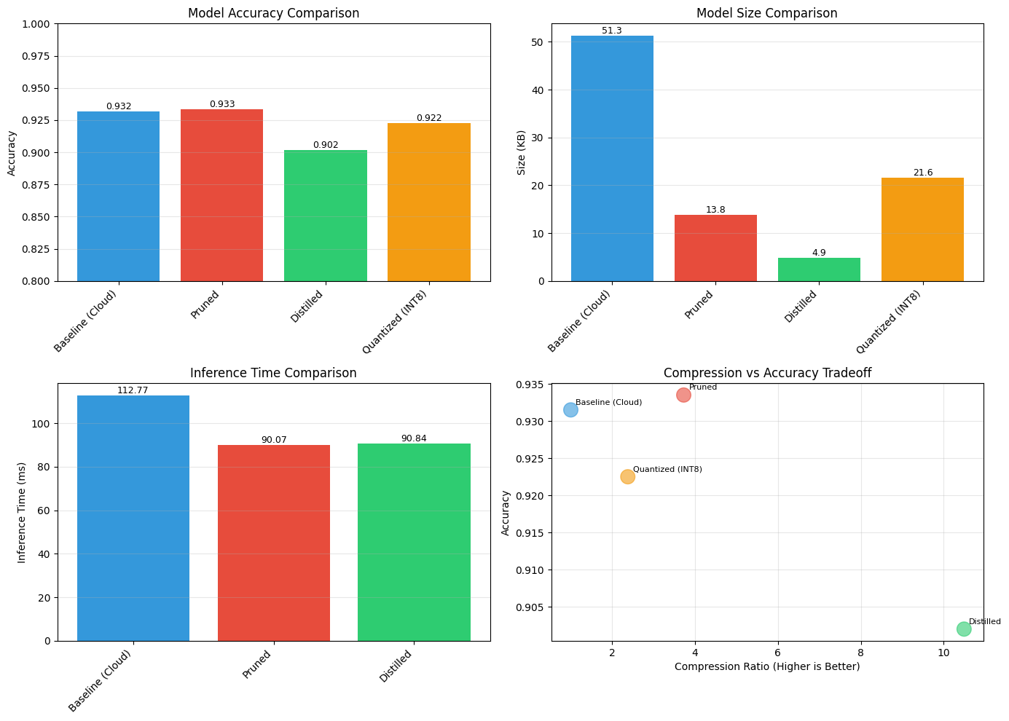
Figure 7.1 — Accuracy, model size, inference time, and compression-vs-accuracy tradeoff across all four model variants.

Results
Model | Accuracy | Inference Time (ms) | Size (KB) | Parameters
Baseline (Cloud) | 0.932 | 112.77 | 51.3 | 13,123
Pruned | 0.933 | 90.07 | 13.8 | 3,523
Distilled | 0.902 | 90.84 | 4.9 | 1,251
Quantized (INT8) | 0.923 | ~0.5* | 21.6 | 13,123

* The quantized model's inference time was estimated separately via the TFLite interpreter rather than measured with the same timing loop as the other models.

Pruning achieved essentially the same accuracy as the baseline (0.933 vs. 0.932) while cutting model size by roughly 73% (51.3 KB → 13.8 KB) and parameters by 73% (13,123 → 3,523). Distillation compressed the model the most aggressively (down to 4.9 KB, a ~10.5x compression ratio) at a cost of about 3 accuracy points. Quantization achieved a good balance — about 4x smaller with only a 1-point accuracy drop, and by far the fastest inference of any variant.

Edge Deployment Recommendations
Device Type | Recommended Model | Reason
Microcontroller (MCU) | Quantized INT8 | Minimal memory footprint (<50 KB), ultra-low power — good for sensor nodes and wearables.
Edge Gateway | Pruned or Distilled | Balance of accuracy and efficiency for industrial IoT / smart-city gateways.
Edge Server | Baseline or Ensemble | Maximum accuracy where resources are sufficient — autonomous vehicles, robotics.

Reflection
This lab made the accuracy/efficiency tradeoff concrete: there is no single 'best' compressed model — the right choice depends entirely on where in the network the model will run. It also connected directly to Module 9's energy-efficiency themes, since smaller, faster models consume less power at the edge.

Module 8: Cybersecurity and AI in Telecommunications

Activities
This module covered network security threats in 5G/6G, privacy and regulatory compliance, AI-based threat detection, and trustworthy/explainable AI, alongside a lab exercise on building a network intrusion detection system (IDS) in Python.

Key Concepts
Threats and Architecture Risks
Traditional network threats include eavesdropping/man-in-the-middle attacks, DDoS, rogue base stations, protocol exploits, and firmware/supply-chain attacks. 5G's cloud-native, Service-Based Architecture and network slicing introduce new attack surfaces, including legacy vulnerabilities inherited from LTE, downgrade attacks, and risks from massive device connectivity. 6G is expected to add ultra-dense networks and terahertz spectrum, pushing toward zero-trust and security-by-design principles.
Privacy and Regulation
Telecom-specific privacy risks include subscriber identity leaks (IMSI/IMEI), traffic-pattern analysis, and location tracking. Regulatory frameworks such as GDPR and CCPA, along with lawful-intercept and data-retention policies, shape how telecom operators must design their systems — echoing the GDPR discussion from the Ethical AI assignment in Module 13.
AI for Threat Detection
AI models used for network security span supervised classification of known attacks, unsupervised anomaly detection for unknown attack patterns, and deep learning approaches (autoencoders, CNNs, LSTMs) for analyzing network traffic. A case study cited in lecture reported around 98% detection accuracy for DoS attacks using a deep-learning IDS trained on the NSL-KDD dataset.
Explainable AI (XAI) for Security Analysts
Because black-box models can be hard for security teams to trust or justify to regulators, model-agnostic explainability tools like LIME and SHAP help analysts understand why an AI system flagged a given alert — directly relevant to the transparency/explainability distinction from the Ethical AI assignment.

Lab Overview: Building an ML-Based IDS
The lab workflow was: (1) load and preprocess a labeled intrusion dataset (KDD Cup 1999 / NSL-KDD), encoding categorical features and splitting into train/test sets; (2) train a supervised classifier (Random Forest or SVM) and evaluate with accuracy, precision, recall, and F1; (3) apply unsupervised methods (Isolation Forest, One-Class SVM) to catch previously unseen attack patterns; and (4) apply SHAP/LIME to visualize which network-flow features drove each classification.

Reflection
Building on Laboratory 3's Random Forest traffic model, this module showed how the same algorithm family can be repurposed from forecasting to classification — the key difference being the label (predicted traffic vs. attack/benign) and the emphasis on explainability, which matters far more in a security context than in a pure forecasting one.

Module 9: Sustainable AI and Green Communications

Activities
This module examined the energy footprint of telecom networks, sustainable network design, renewable energy integration, and how AI itself can be used to reduce energy consumption — balanced against AI's own energy cost.

Key Concepts
Where the Energy Goes
Base stations account for roughly 60–80% of telecom energy consumption, data centers 15–20%, and transmission 5–10%, with cooling adding another 30–40% on top of IT load. ICT overall is estimated at 2–4% of global greenhouse-gas emissions, with telecom specifically around 0.2–0.3%.
Efficiency Metrics
- PUE (Power Usage Effectiveness) = Total Facility Energy / IT Energy — under 1.5 is considered good; reducing PUE from 2.0 to 1.3 can save megawatts per year at scale.
- ECR (Energy Consumption Ratio) — joules per bit transmitted.
- CUE (Carbon Usage Effectiveness) — CO₂ emitted per unit of IT energy.
AI-Driven Energy Optimization
AI techniques applied to energy management include load/consumption forecasting (LSTM, Prophet), clustering usage patterns (K-means), and anomaly detection (autoencoders) — feeding into a traffic → ML → forecast → optimize pipeline. Power-management techniques include dynamic cell sleeping and adaptive power/cooling control; reinforcement learning (DQN, PPO, Actor-Critic) can treat energy minimization as a reward function while keeping QoS as a constraint. One cited example: DeepMind's RL-based cooling optimization cut data-center cooling energy by about 40%.
Renewable Integration and Circular Economy
Examples included solar/wind-powered base stations, hybrid off-grid setups, battery energy storage for peak shaving, and smart-grid demand response (e.g., Ericsson solar towers reportedly cutting diesel use by 80% at some sites). Circular-economy practices — predictive maintenance, refurbishment/reuse, and e-waste management — reduce the embedded environmental cost of network hardware.

Lab & Discussion Themes
The associated lab focused on analyzing energy data, forecasting consumption, optimizing for cost/carbon, and assessing environmental impact using pandas, TensorFlow, and Prophet. Discussion topics included the tradeoff between AI's own energy consumption and the savings it enables, equity of access to renewable-powered infrastructure, and the 'rebound effect' where efficiency gains can be offset by increased usage.

Reflection
This module reframed earlier modules' AI techniques (forecasting in Module 3, model compression in Module 7) through an energy lens: a smaller, faster edge model isn't just cheaper to run — it is also more sustainable, which connects directly back to the compression-tradeoff table from Laboratory 5.

Module 10: Advanced AI Applications in Next-Generation Networks

Activities
This module surveyed more advanced, forward-looking AI applications: digital twins, AI-enhanced network slicing, cognitive radio/spectrum management, AI combined with blockchain and quantum computing, and neuromorphic/bio-inspired computing. The associated lab used conceptual digital-twin modeling in Python.

Key Concepts
Digital Twins
A digital twin is a virtual replica of a physical network system, kept in sync via a data pipeline and an AI engine, and used for predictive maintenance, capacity planning, fault diagnosis, and energy management.
AI-Enhanced Network Slicing
Building on the network-slicing concept from Module 2, AI (reinforcement learning, deep neural networks) improves slice-level resource allocation, performance prediction, and cost optimization — for example, in a 5G smart-factory use case.
Cognitive Radio and Spectrum Management
Cognitive radios learn and adapt their frequency usage; AI supports spectrum sensing, decision-making, and spectrum sharing, using algorithms such as Q-learning, Deep Q-Networks, and transfer learning.
AI + Blockchain and Quantum Computing
AI combined with blockchain supports secure IoT data sharing, fraud detection, and smart contracts. AI combined with quantum computing is an emerging area for quantum optimization, network prediction, and quantum-enhanced reinforcement learning.
Neuromorphic and Bio-Inspired Computing
Neuromorphic systems use spiking neural networks for very low-power computation — directly relevant to the edge-deployment tradeoffs explored in Module 7 — while bio-inspired algorithms (Ant Colony Optimization, Genetic Algorithms, Particle Swarm Optimization) offer alternative optimization strategies for network problems.

Hands-On Lab Overview
The lab used SimPy for discrete-event network traffic simulation, Mesa for agent-based modeling of adaptive router agents under congestion, and a regression model for predictive traffic optimization — echoing the traffic-prediction work from Laboratory 3 and Module 5, now framed as part of a larger digital-twin simulation.

Reflection
This module tied together threads from across the course — traffic prediction, slicing, edge efficiency — inside the unifying idea of a digital twin, which made clear how these individually-taught techniques would actually combine in a real next-generation network operations center.

Module 11: 6G Vision and AI-Native Networks

Activities
This module looked ahead to 6G: its target requirements, an AI-native architecture (AI embedded at every network layer rather than bolted on afterward), terahertz communications, massive connectivity with satellite integration, and federated learning.

Key Concepts
6G Requirements and KPIs
- Peak data rate target: 1 Tbps.
- Latency goal: 0.1 ms.
- Connection density: 10⁷ devices per km².
AI-Native Architecture
Unlike 5G (where AI is layered on top of the network), 6G is envisioned with AI woven into every layer, supporting self-optimizing and self-healing networks and intent-based orchestration — where operators express a desired outcome and the network figures out how to achieve it.
Terahertz Communications
Frequencies from roughly 0.1–10 THz can deliver terabit-per-second speeds but face challenges such as molecular absorption and very short range; proposed solutions include Reconfigurable Intelligent Surfaces (RIS), adaptive transmission, and advanced beamforming.
Distributed AI and Federated Learning
6G distributes AI across cloud, edge, and device layers to reduce latency and protect privacy. Federated learning lets devices train locally and share only aggregated model updates — supporting privacy-preserving predictive maintenance and resource optimization without centralizing raw data.

Hands-On Lab Overview
The lab involved conceptual 6G network design, a federated-learning simulation, and performance visualization/discussion.

Reflection
Learning about federated learning gave me a privacy-preserving counterpart to the centralized model training used in Laboratory 3 and Laboratory 5 — an important consideration given the privacy concerns raised throughout Module 8 and the Ethical AI material in Module 13.

Module 12
No materials were assigned to Module 12 in the course materials provided for this portfolio.

Module 13: Ethical AI and Future Trends

Activities
This module covered ethical AI principles and frameworks, major AI ethics case studies, and future trends and regulation. I completed Assignment 4, a 30-question written assignment spanning conceptual, applied/scenario-based, and reflective questions.

Key Concepts from Lecture
Ethical Challenges and Case Studies
Core challenges covered were bias and discrimination, privacy and surveillance, transparency and explainability, accountability and liability, and misuse of AI. These were illustrated with four real case studies: the COMPAS recidivism algorithm (bias against minority defendants in US courts), Cambridge Analytica (data misuse and privacy breach), the ethical dilemmas of autonomous-vehicle accidents, and generative AI's issues around misinformation and authorship.
Ethical Frameworks
The lecture and my assignment both referenced the same core set of frameworks: the IEEE Ethically Aligned Design initiative, the EU AI Ethics Guidelines / EU AI Act, the OECD AI Principles, and UNESCO's Recommendation on the Ethics of Artificial Intelligence, alongside corporate frameworks such as Google's AI Principles, Microsoft's Responsible AI framework, and IBM's AI Ethics Board.

Assignment 4: Ethical AI — Selected Highlights
Conceptual Understanding
Ethical AI means designing and using AI fairly, safely, and transparently, with respect for human rights — essential because AI decisions affect people's jobs, healthcare, and privacy. Four core principles are fairness (no discrimination), transparency (openness about AI use), accountability (developers/organizations are responsible for outcomes), and privacy (protecting personal data). I distinguished transparency (being open about how AI is built and used) from explainability (being able to explain why a specific decision was made).
OECD's five principles for trustworthy AI are inclusive growth and well-being; human-centered values and fairness; transparency and explainability; robustness, security, and safety; and accountability. The EU AI Act classifies systems into unacceptable, high, limited, and minimal risk, with stricter obligations for higher-risk systems.
Applied and Scenario-Based
For a biased recruitment AI, I identified violations of fairness, non-discrimination, accountability, and transparency. The self-driving-car dilemma of choosing between hitting one pedestrian or five is the classic trolley problem. In predictive policing, bias enters training data when historical policing itself was biased, so the model learns to repeat that bias. A 'human-in-the-loop' design reduces risk by having a person review important automated decisions before they're finalized — the same concept that appeared as an accountability mechanism in Module 8's security lecture.
Reflective and Future-Oriented
I argued that AI can likely never be completely unbiased, since it learns from human-generated data — the realistic goal is to minimize bias rather than eliminate it. I discussed how a combination of government regulation and industry self-regulation works better than either alone. Looking ahead to 2035, I identified AI-generated misinformation as the most pressing likely issue, given its potential to influence elections and public trust — a concern echoed in the lecture's discussion of generative-AI case studies (deepfakes, authorship, and authenticity verification).

Reflection
Working through this assignment alongside the Module 13 lecture — and looking back at Module 8's security/privacy material and Module 9's sustainability material — made clear how much overlap there is between 'ethical AI' as a distinct topic and the fairness, transparency, and accountability concerns that showed up quietly throughout the entire course, from network-slicing fairness in Module 2 to explainability in Module 8's intrusion-detection lab.

References
Assignment and lecture material citations, as referenced throughout this portfolio:
- IEEE. Ethically Aligned Design — A Vision for Prioritizing Human Well-being with Autonomous and Intelligent Systems.
- UNESCO. Recommendation on the Ethics of Artificial Intelligence (2021).
- OECD. OECD AI Principles (2019, updated 2024).
- European Commission. EU Artificial Intelligence Act.
- O-RAN Alliance. O-RAN specifications and documentation — https://www.o-ran.org
- 3GPP. Technical specifications for 5G Core and RAN architecture.
- Mobara, P., Moskolaï Ngossaha, J., Djeumen Djatcha, R., Tchappi, I., & Bowong Tsakou, S. (2025). AI-Driven Load Balancing in Paravirtualized 5G Networks: Architecture, Implementation, and Future Prospects. Procedia Computer Science, 257, 599–606. https://doi.org/10.1016/j.procs.2025.03.077
- Floridi, L., & Cowls, J. (2019). A Unified Framework of Five Principles for AI in Society. Harvard Data Science Review.
- Jobin, A., Ienca, M., & Vayena, E. (2019). The Global Landscape of AI Ethics Guidelines. Nature Machine Intelligence.
- Course lecture slide decks: Module 2 (Network & Wireless Basics), Module 5 (Open RAN & AI), Module 8 (Cybersecurity & AI), Module 9 (Sustainable AI & Green Communications), Module 10 (Advanced AI Applications), Module 11 (6G & AI-Native Networks), Module 13 (Ethical AI & Future Trends).

